**October 29th, 2024 Team 10 Meeting Agenda - Welcome back Chris!**

1. **Review proposal feedback**
   1. How did we do? Any areas where we exceeded or could improve? Any urgent changes to be made to any methods/aims?
   2. Plan for revision and resubmission based on feedback
2. **Present Figures**
   1. Preliminary findings/trends
   2. Which diversity metrics should we narrow down to?
   3. Plans for moving forward
      1. Continue with the aims we are working on? Is it best to start on writeups for each section after all analyses are done? We are here**↓**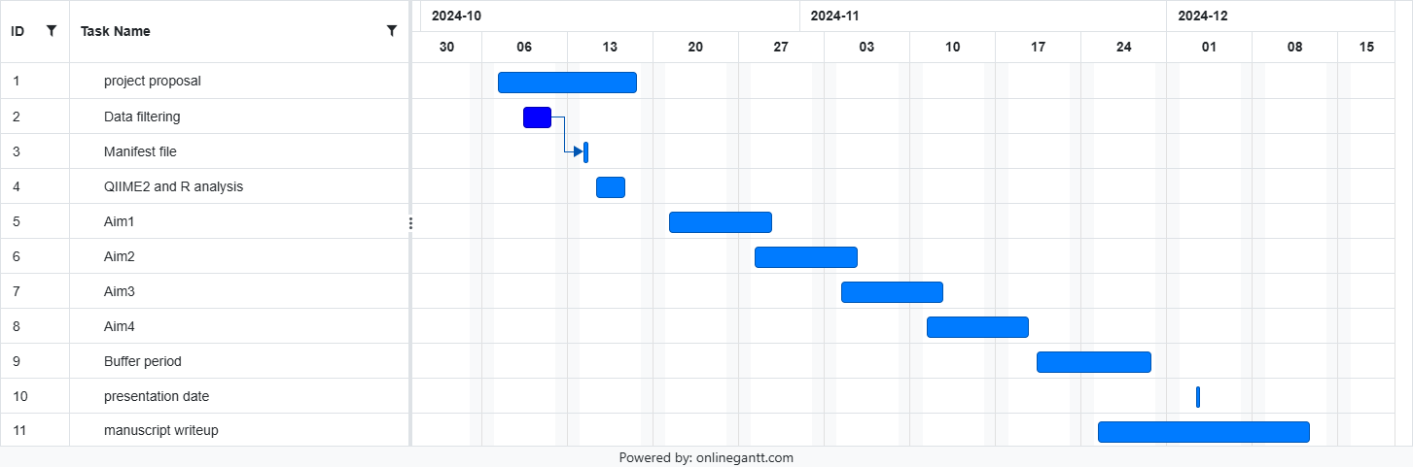
      2. Edit gantt chart to reflect how we are currently working through the aims